INITIAL ASSESSMENT REPORT

APPLICATION A530

PERMISSION FOR KEENS FARMHOUSE CHEDDAR AND MONTOGOMERY CHEDDAR

Executive Summary

Purpose

Application A530 seeks a variation of the Australia New Zealand Food Standards Code (the Code) to include Keen’s Farmhouse Cheddar and Montgomery Cheddar in the table to clause 3 of Standard 2.5.4. This application was made by Mr Will Studd, trading as Fromagent Australia, on 30 January 2004.

Keen’s Farmhouse Cheddar and Montgomery Cheddar are unpasteurised or raw milk cheeses made in the United Kingdom.

Primary production and processing standards

Assessment of A530 was deferred pending FSANZ’s development of a Dairy Primary Production and Processing Standard (through Proposal P296), which included raw milk products within scope. Standard 4.2.4 – Primary Production and Processing Standard for Dairy Products was finalised in 2006 and came into effect on 5 October 2008. Processing measures for cheese, previously specified in Standard 1.6.2 of the Code, were included in Standard 4.2.4. The table that set out requirements for specific cheeses previously in Standard 2.5.4, was included in Standard 4.2.4A Primary Production and Processing Standard for Specific Cheeses.

During the development of Standard 4.2.4 it was decided to assess raw milk products as a separate process once Standard 4.2.4 was completed. This was a staged process that included two proposals:

- Proposal P1007 Primary Production and Processing Requirements for Raw Milk products was finalised in June 2012 and established a risk-based category approach to assess permissions for raw milk products. This approach permitted a greater range of curd cooked cheeses made from raw milk.

- Proposal P1022 Primary Production and Processing Requirements for Raw Milk Products was finalised in December 2014 and resulted in amendments to Standard 4.2.4 that allowed raw milk cheese to be produced and sold in accordance with additional food safety requirements that were included in Division 5 of the standard. These measures made Standard 4.2.4A redundant and it was repealed.

Importation of raw milk cheese

Following P1022, the Department of Agriculture and Water Resources (DAWR) finalised import conditions for raw milk cheese which include an assessment process for equivalence with the food safety requirements for raw milk cheese in the Code. Countries wishing to export raw milk cheese to Australia, and cheese importers, now need to contact DAWR for an assessment of equivalence.

Reasons for assessment

After considering the requirements for Initial Assessment as prescribed in section 13 of the Food Standards Australia New Zealand Act 1991 (FSANZ Act) (as was in force prior to 1 July 2007), FSANZ has decided to reject the application because it does not relate to a matter that warrants a variation of the Code. This is because:

- The Code now contains general provisions in relation to the processing of raw milk cheeses in Standard 4.2.4. None of the provisions that were relevant to the processing of raw milk cheeses in 2004 and to which A530 relates, remain in the Code. Nor does the Code now include provisions for specific reference to types of cheeses produced in accordance with specified legislation.

- The purpose of A530 was to enable the importation and sale of two raw milk products, namely Keen’s Farmhouse Cheddar and Montgomery Cheddar. As a result of proposals P1007 and P1022, a risk-based framework for the manufacture, importation and sale of raw milk cheese is now in place in Australia.
- No evidence has been submitted to FSANZ that would warrant a change to or reconsideration of the risk assessment and risk management conclusions stated in the approval reports for P1007 and P1022 or to the Code provisions relating to the manufacture and sale of raw milk cheese

CONTENTS

Executive Summary 2

Reasons for Assessment 2

1. Introduction 5

2. The Issue / Problem 7

3. Objectives 7

4. Options 8

5. Conclusion and Decision 9

1. Introduction

Food Standards Australia New Zealand (FSANZ) received an application (A530) from Mr Will Studd on12 February 2004 requesting an amendment to the Australia New Zealand Food Standards Code (the Code) to permit the sale of specific raw milk cheddar cheeses.

1.1 Background

Application A530 sought to vary the Table to clause 3 of Standard 2.5.4 of the Code to permit the importation and sale of the raw milk cheeses, Keens Farm Cheddar and Montgomery Cheddar.

As explained below, assessment of Application A530 was deferred pending the development of a Dairy Primary Production and Processing Standard in Proposal P296. That proposal included consideration of the issue of raw milk products, such as cheese.

Proposal P296 resulted in Standard 4.2.4 – Primary Production and Processing Standard for Dairy Products, which took effect on 5 October 2008. FSANZ’s assessment of raw milk products continued with Proposal P1007 - Primary Production & Processing Requirements for Raw Milk Products and P1022 - Primary Production & Processing Requirements for Raw Milk Products.

In 2015, the applicant advised FSANZ that he intended to withdraw Application A530 given the conclusion and outcomes of P1022, but was waiting to confirm that these outcomes were reflected in import permit conditions issued by Department of Agriculture.

In May 2018, the applicant advised that he would not withdraw Application A530. The applicant’s reasons were that: Application A530 had not been addressed by the risk assessments conducted for Proposals P296, P1007 and P1022; and that the regulations that resulted from these proposals were out of step with international standards and acted as barriers to the production, sale and importation of raw milk cheese. The applicant did not provide any evidence to support or substantiate these claims.

As a result, FSANZ is required to assess the application. As Application A530 was lodged in 2004, FSANZ is required to assess the application under the law that was in force at that time and before the Act was amended on 1 July 2007, when the current assessment procedures were introduced.

1.2 The applicable standards
At the time Application A530 was lodged, Standard 2.5.4 specified the following provisions:

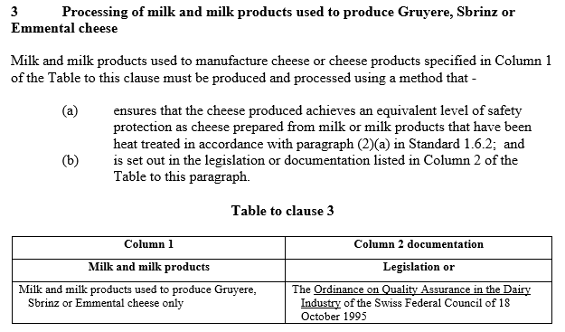

Processing requirements for cheese and cheese products were specified in Standard 1.6.2:

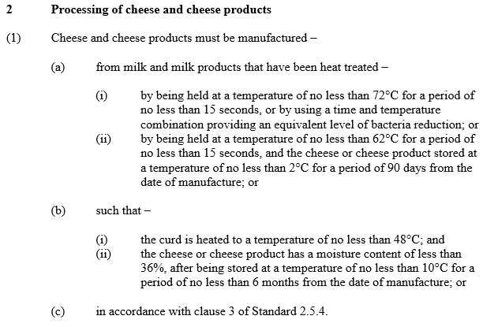
These requirements meant that only cheese that was made from pasteurised or thermised milk; or met specified curd cooking requirements; or was listed in the Table to clause 3 of Standard 2.5.4 could be sold.

Assessment of the application was deferred pending FSANZ’s development of a Dairy Primary Production and Processing Standard (through Proposal P296) which included raw milk products within scope.

1.3 Current standards

Standard 4.2.4 was finalised in 2006 and came into effect on 5 October 2008. It contains measures to address food safety for the dairy industry from production of milk through to processing, including manufacture of specified dairy products. These measures included processing requirements for cheese previously specified in Standard 1.6.2. The requirements in clause 3 of Standard 2.5.4 and the Table to clause 3 were included in Standard 4.2.4A Primary Production and Processing Standard for Specific Cheeses.

During the development of Standard 4.2.4 it was decided to assess raw milk products as a separate process once Standard 4.2.4 was completed. Subsequently, FSANZ prepared proposal P1007. P1007 established a risk-based category approach to assess permissions for raw milk products. P1007 was finalised and Standard 4.2.4 amended in June 2012 such that a greater range of curd cooked cheeses made with raw milk were permitted.

The second stage of assessing raw milk products was progressed through Proposal P1022. P1022 was finalised in December 2014 and resulted in amendments to Standard 4.2.4. These amendments included provisions that enable raw milk cheese to be produced and sold in accordance with additional requirements that were included in Division 5 of Standard 4.2.4, and providing the cheese met the following outcomes:

- The level of pathogenic microorganisms in a raw milk cheese must not exceed the level of pathogenic microorganisms in the milk from which the product was made as at the commencement of the processing of that milk.
- A raw milk cheese must not support the growth of pathogenic microorganisms.

Standard 4.2.4A was repealed as requirements for raw milk cheese were now covered by animal health and processing controls specified in Standard 4.2.4.

2. The Issue / problem

The Code now permits the production and sale of any raw milk cheese provided that specified animal health and food safety controls are met. There is no longer a requirement for a table in the Code to list specific cheese types and the legislation that covers their manufacture.

In addition, raw milk cheese can now be imported into Australia. The Department of Agriculture and Water Resources (DAWR) has finalised import conditions for raw milk cheese which includes an assessment process for equivalence with the food safety requirements for raw milk cheese in the Code:
http://www.agriculture.gov.au/import/goods/food/inspection-compliance/risk-food/rmc
Countries wanting to export raw milk cheese to Australia can apply to DAWR for an assessment of equivalence. Imports of raw milk cheese must be covered by a recognised foreign government certificate.

Application A530 sought to vary a provision in the Code which no longer exists.

The importation and sale of Keens Farm Cheddar and Montgomery Cheddar can now be managed through requirements in Standard 4.2.4 and DAWR import conditions.

3. Objectives

In developing or varying a food standard, FSANZ is required by its legislation to meet three primary objectives in subsection 18(1) of the FSANZ Act (set out in section 10 of the FSANZ Act prior to 1 July 2007). These are:

- the protection of public health and safety

- the provision of adequate information relating to food to enable consumers to make informed choices

- the prevention of misleading or deceptive conduct.

In developing and varying standards, FSANZ must also have regard to:

- the need for standards to be based on risk analysis using the best available scientific evidence

- the promotion of consistency between domestic and international food standards

- the desirability of an efficient and internationally competitive food industry

- the promotion of fair trading in food

- any written policy guidelines formulated by the Australia and New Zealand Ministerial Forum on Food Regulation (Forum).

Each of these objectives and matters were considered in the assessment of proposals P1007 and P1022, which resulted in amendments to the Code which now allow for the production and sale of raw milk cheese (domestically produced and imported) in Australia providing specified public health and safety outcomes are met.

The assessment of proposals P1007 and P1022, and the decision to approve the above-mentioned amendments, also had regard to the following matters:
- whether costs that would arise from a food regulatory measure developed or varied as a result of the proposals outweigh the direct and indirect benefits to the community, Government or industry that would arise from the development or variation of the food regulatory measure;
- whether other measures (available to FSANZ or not) would be more cost-effective than a food regulatory measure developed or varied as a result of the proposals;
- any relevant New Zealand standards;
- any other relevant matters.
Each of the assessment and approval reports for proposals P1007 and P1022 are publically available on the FSANZ website.

4. Options

Sections 13 and 13A of the FSANZ Act (as was in force prior to 1 July 2007) require FSANZ to make an initial assessment of the application in order to decide whether to accept or reject the application.

In making that assessment, FSANZ must have regard to the matters listed in subsection 13(2) of the FSANZ Act. These are:

(a) whether the application relates to a matter that may be developed as a food regulatory measure, or that warrants a variation of a food regulatory measure;

(b) whether the application is so similar to a previous application that it should not be accepted;

(c) whether the costs that would arise from a food regulatory measure would outweigh the direct and indirect benefits to the community, Government or industry;

(d) whether other measures (available to FSANZ or not) would be more cost-effective than a food regulatory measure;

(e) any other relevant matters.

5. Assessment

FSANZ’s assessment was that the application should be rejected on the basis that it does not relate to a matter that warrants a variation of the Code. This is because:

- The Code now contains general provisions relating to the processing of raw milk cheeses in Standard 4.2.4 and which, in effect, permit the sale of raw milk products. None of the provisions that were relevant to the processing of raw milk cheeses in 2004 and to which A530 relates, remain in the Code. Nor does the Code now include permissions that make specific reference to types of cheeses produced in accordance with specified legislation.

- The purpose of A530 is to enable the importation and sale of two raw milk products. As a result of proposals P1007 and P1022, a risk-based framework is now in place in Australia to manage the importation and sale of raw milk products, including the two products in question.

In making that assessment, FSANZ had regard to the following:

- the application
- correspondence from the applicant in relation to the application, including his contention that his Application had not been addressed by the risk assessments conducted for proposals P296, P1007 and P1022; and that the regulations that resulted from these proposals were out of step with international standards and acted as barriers to the production, sale and importation of raw milk cheese
- the assessment and approval reports for proposals P1007 and P1022, and the analysis and conclusions stated in each, including in relation to consistency between domestic and international food standards and an efficient and internationally competitive food industry
- the applicable provisions of the Code (summarised above)
- the FSANZ Act (as was in force prior to 1 July 2007), including each of the matters prescribed in subsection 13(2) of that Act.

6. Decision

FSANZ decided to reject the application for the reasons stated above.

http://www.foodstandards.gov.au/code/proposals/pages/proposalp296primaryp2806.aspx
http://www.foodstandards.gov.au/code/proposals/Pages/proposalp1007primary3953.aspx
http://www.foodstandards.gov.au/code/proposals/pages/proposalp1022primary5627.aspx

